

Property Management Information System (PMIS)
For Noida Authority

Digitization Process Plan

Table of Contents
Introduction 3
1. Digitization activity plan 3
1.1 What is to be digitized? 3
1.2 Why digitize? 3
2. Digitization image specifications 4
3. Digitization process plan 4
3.1 Process set up 4
3.2 Retrieval of records 4
3.3 Scanning records 4
3.4 Post processing of records 5
3.5 Reprocessing a source record 6
4. Quality control and assurance plan 6
4.1 Image accuracy 6
5. Digitization Plan Diagram 7
6. Digitization Document List For all Department 8

Introduction
This Digitization Plan of Department Wise Property Record Digitization process has been produced as part of Noida Authority documentation.
Its primary aim is to inform Noida Authority staff about the Digitization process. This defines, how Department Wise Property Record will be digitized and whether it meets the Standards.
This plan will define the scope of Digitization activity for Department Wise Property Record as well as identify the risks involved in the process. The plan introduces procedures for handling the records pre and post processing as well as recommending scanning parameters. It explains the quality assurance measures taken to ensure the clarity and accuracy of the converted (electronic) records.

Digitization activity plan

What is to be digitized?
The Noida Authority Property Files Digitization Program covers:
- All hardcopy Property records imaged and registered.
- It will also apply to the future digitization of hardcopy Property records. The plan is for Noida Authority staff to digitize these records at the first point of contact with any onshore faculty or central administrative units.
While the core Property record is held in, the documents on the Property file provide supporting evidence for these records.

Why digitize?
A review of Property records was undertaken in 2014/15 with a view to standardization of Property recordkeeping across the Noida Authority campuses. The review recommended that Property files be managed in Document records management System
- ability to save physical space, by reducing the retention of paper records from 7 years to 6 months
- improved access to a central, authoritative source for users of the digitized records
- Provision of a secure electronic storage place for the images, within a proven and reliable recordkeeping system.

Digitization image specifications
Resolution Required | Type of Image | Output Format
200-dpi* | Color | PDF multi-page image
300-dpi* | black and white | PDF multi-page image
Exceptions: It may be necessary to increase the dpi to 300 dpi, and/or revert to color scanning/greyscale if this is required in order to improve the legibility of the image. Also in regards to bit depth - 8 bits can be used for greyscale and 24 bits for color (where the scanning devices permit the bit depth option to be changed - otherwise the fixed bit-depth settings for greyscale and color will be used).

Digitization process plan

Process set up
The digitization hardware being used for this program mainly consists of standard Authority standard multi-function devices that can scan to the specifications.
All Authority multi-function devices used for scanning have in-built capability to create PDF documents.

Retrieval of records
No retrieval of records is required for the Digitization process. Hardcopy Property file documents are to be digitized at Noida Authority at the point of first contact with the Authority.

Scanning records
Procedures for scanning are as follows:
- ensure that single-sided documents are scanned as single-sided documents and that double-sided documents are scanned as double-sided documents
- documents must be saved in PDF format
- Ensure that post-it notes with annotations are captured along with the document. Ensure that the post-it note does not obscure any information on the document. If it is not possible to do one scan of both the post-it note and the document without obscuring information, then it will be necessary to do two scans of the same page: one with the post-it note attached and one without the post-it note. Ensure that both scans are saved in the same multi-page PDF
- Ensure that all records with informational value are scanned eg. records such as registered post dockets should be scanned
- Ensure that the contents of oversized documents are captured in full. Where the entire document does not fit on the platen of the scanning device, such as foolscap paper, photocopy the document and reduce it to A4 in the photocopying process, and then scan the reduced photocopy. If there is no other way of capturing an oversized document in full, do more than one scan of the same oversized page so that all of the content is captured and ensure that all scans of the same page are saved in the same multi-page PDF
- digitize parts of forms not completed by the student, as evidence of what the student did and did not fill in
- do not digitize leading pages with instructions for the completion of forms, or blank pages at the back of forms
- Scanning can be done using document feeders whenever possible provided that the document feeder captures the complete content of the document, and does not damage the document. Examples when document feeders should not be used include: documents with post-it notes attached and non-standard sized documents (e.g. documents which are larger or smaller than A4 size). Reasonable care must be taken when scanning the source documents. If any damage occurs to the source record, during the scanning process, the documents must repaired immediately.
After scanning, images must be saved to a secure Noida Authority network drive. The area on the network drive where these images are saved, MUST NOT be accessible to anyone, other than approved Department officers, who have the right to access Property file information. Saving to a network drive. Ensures that the data is backed up overnight, and should be retrievable in the event of a disaster. If a staff member chooses to save the file to their own computer, the staff member must ensure that all necessary procedures are taken, to ensure that the data saved there is not accessible to anyone other than approved Department officers, who have the right to access the Property file information. It is strongly recommended, that no more than an hour's worth of scanning is stored on a staff members' own computer, in the event of a computer breakdown, this should reduce the amount of rescanning required.
Staff need to be aware, that the storage of any scanned images, anywhere, should only ever be viewed as a very short term, temporary measure.
Images should not be saved or stored on a transferable storage medium, such as a memory stick or CD.
Records and Archives Services recommends titling the images with the agreed Authority naming conventions for Property documents even while on the shared drive or computer to make identification easier.

Post processing of records
If staples were removed from a multi-page hardcopy document before scanning, then the document should be re-stapled after scanning; this assists in the quality control check of the Digitization process.
Once scanned, records should be boxed in order of scanning. When full, a box should be labelled on the outside.

Reprocessing a source record
Every page of every image, must be checked immediately after scanning, to ensure that all of the content has been captured correctly and that the content is legible. If the scanned image is illegible, the document must be rescanned immediately. If a document is rescanned, then the person doing the scanning must determine whether they need to increase the resolution to 300 dpi and/or change the image to greyscale or color to ensure legibility.

Quality control and assurance plan

Image accuracy
To ensure image accuracy the image:
- must capture all of the content of the source records
- The image must be legible.
Records and Archives Services sample 100% of the digitized images as part of the quality control process.

Digitization Plan Diagram
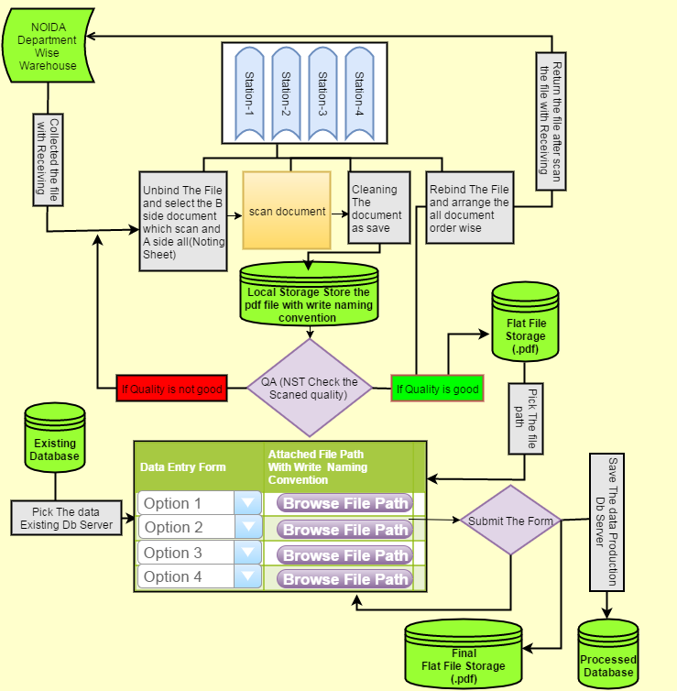

Digitization Document List For all Department
Institutional | Industrial | Residential | Commercial | Housing | File naming convention  RID-NO
Noting Sheet(All) | Noting Sheet(All) | Noting Sheet(All) | Noting Sheet(All) | Noting Sheet(All) | 10000000-000
 |  |  |  | Provisional Allotment | 10000000-001
Allotment | Allotment | Allotment | Allotment | Allotment | 10000000-002
 |  |  |  | HPTA | 10000000-003
Lease Deed | Lease Deed | Lease Deed | Lease Deed | Lease Deed | 10000000-004
Possession Letter | Possession Letter | Possession Letter | Possession Letter | Possession Letter | 10000000-005
Mortgage Letter | Mortgage Letter | Mortgage Letter | Mortgage Letter | Mortgage Letter | 10000000-006
Transfer Letter | Transfer Letter | Transfer Letter | Transfer Letter | Transfer Letter | 10000000-007
 | Transfer With GPA Letter | GPA incase transferred through GPA + Transfer Deed | Transfer With GPA Letter | Transfer With GPA Letter | 10000000-008
Transfer Deed | Transfer Deed | Transfer Deed | Transfer Deed | Transfer Deed | 10000000-009
Functional | Functional |  | Functional |  | 10000000-010
CIC | CIC |  | CIC |  | 10000000-011
 |  | Co-allotter Permission |  | Co-allotter After Death | 10000000-012
Rent Permission | Rent Permission |  | Rent Permission |  | 10000000-013
Sub Lease |  |  | Sub Lease |  | 10000000-014
Completion | Completion | Completion | Completion |  | 10000000-015
 |  | Mutation (Final) | Mutation | Mutation for Death cases only | 10000000-016
NDC | NDC | NDC | NDC | NDC | 10000000-017

